BASIC PySpark Commands
1. Start Spark Session
from pyspark.sql import SparkSession

spark = SparkSession.builder \
.appName("MyApp") \
.getOrCreate()

2. Read Data
df = spark.read.csv("file.csv", header=True, inferSchema=True)
df = spark.read.json("file.json")
df = spark.read.parquet("file.parquet")

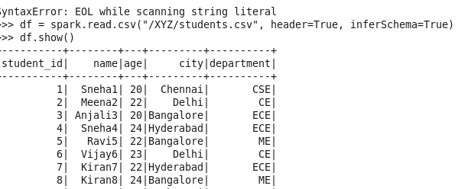

3. Show Data
df.show()
df.printSchema()
df.columns
df.describe().show()



4. Select Columns
df.select("name", "age").show()

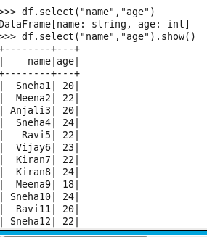

5. Filter Data
df.filter(df.age > 25).show()
df.where("age > 25").show()

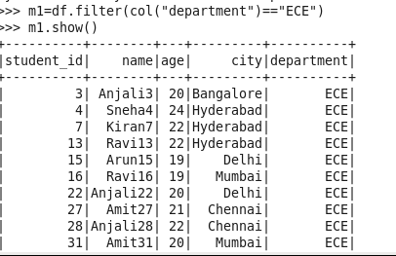

6. Add / Modify Column
from pyspark.sql.functions import col

df = df.withColumn("age_plus_1", col("age") + 1)

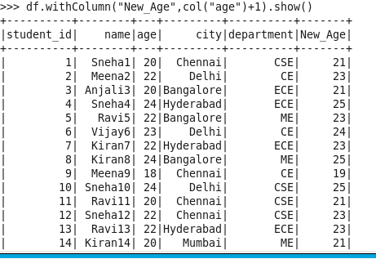

7. Drop Column
df = df.drop("age")

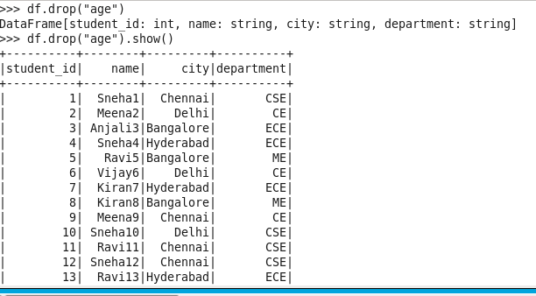

8. Rename Column
df = df.withColumnRenamed("old", "new")

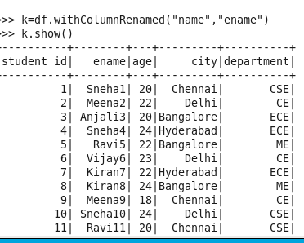

9. Count Rows
df.count()
>>> df.count()
50

10. Remove Duplicates
df.dropDuplicates()

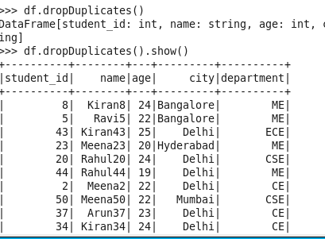

INTERMEDIATE COMMANDS
11. Group By + Aggregation
from pyspark.sql.functions import avg, sum

df.groupBy("department").agg(
avg("salary"),
sum("salary")
).show()

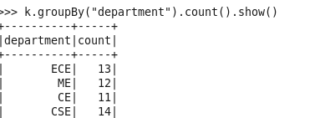

12. Sorting
df.orderBy("salary")
df.orderBy(col("salary").desc())

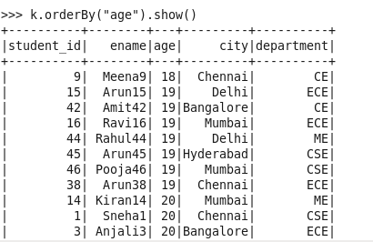

13. Joins
df.join(df2, on="id", how="inner")
df.join(df2, on="id", how="left")

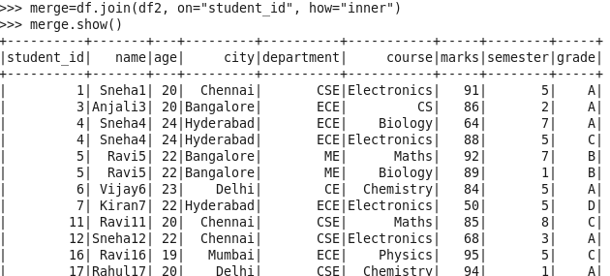

14. Handling Nulls
df.dropna()
df.fillna(0)

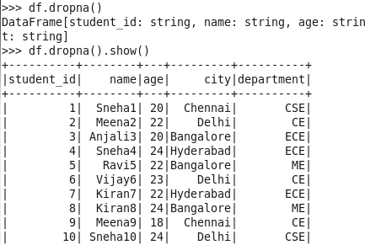

15. Distinct Values
df.select("department").distinct()
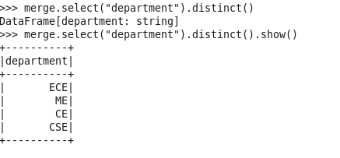

16. Cache Data
df.cache()
df.persist()

17. Repartition / Coalesce
df.repartition(4)
df.coalesce(2)

18. UDF (User Defined Function)
from pyspark.sql.functions import udf
from pyspark.sql.types import IntegerType

def double(x):
return x * 2

double_udf = udf(double, IntegerType())

df = df.withColumn("double_age", double_udf(df.age))

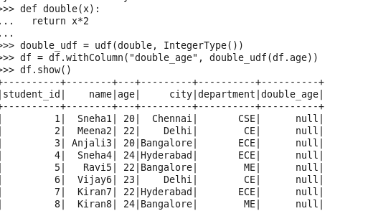

19. Write Data
df.write.csv("output/")
df.write.parquet("output/")

20. SQL Queries
df.createOrReplaceTempView("table")

spark.sql("SELECT * FROM table WHERE age > 25").show()

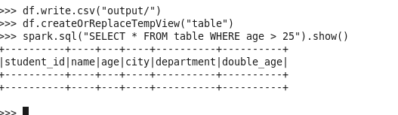

ADVANCED COMMANDS
21. Window Functions
from pyspark.sql.window import Window
from pyspark.sql.functions import row_number

windowSpec = Window.partitionBy("dept").orderBy(col("salary").desc())

df.withColumn("rank", row_number().over(windowSpec))

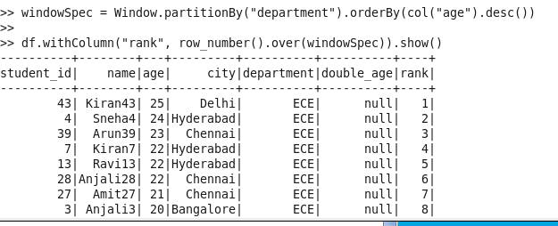

22. Broadcast Join
from pyspark.sql.functions import broadcast

df.join(broadcast(df2), "id")

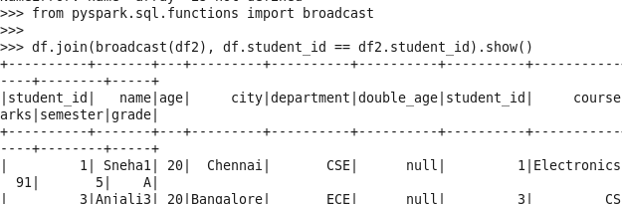

23. Explode (for arrays)
from pyspark.sql.functions import explode

df.select(explode(df.skills)).show()

24. Pivot Table
df.groupBy("dept").pivot("gender").count()

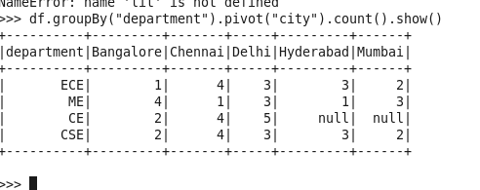

25. Complex Filtering
df.filter((df.age > 25) & (df.salary > 50000))

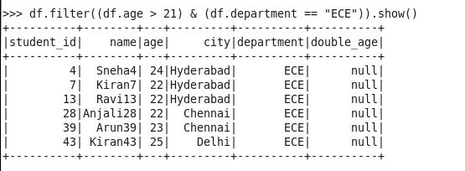

26. Column Expressions
df.selectExpr("age * 2 as double_age")

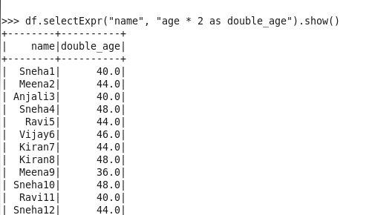

27. Handling Dates
from pyspark.sql.functions import current_date

df.withColumn("today", current_date())

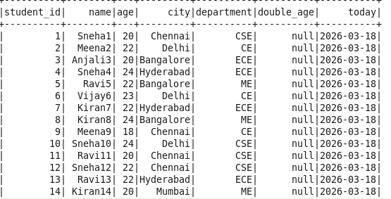

28. Checkpointing
spark.sparkContext.setCheckpointDir("chk/")

df.checkpoint()

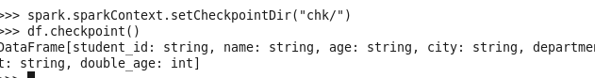

29. Accumulators
acc = spark.sparkContext.accumulator(0)

def add(x):
global acc
acc += x

rdd.foreach(add)

30. Read Large Data Efficiently
spark.read.option("partitionColumn", "id") \
.option("lowerBound", 1) \
.option("upperBound", 1000) \
.option("numPartitions", 4) \
.jdbc(url, table, properties)

